

**Accounting Reports**

***Accounting Reports Management***

# **Document Information**

|  |  |
| --- | --- |
| Document Name | Accounting Reports |
| Document Author | Md. Golam Rabbi |
| Document Version | 1.0 |
| Release Date | April 9, 2018 |

|  |  |
| --- | --- |
| Review by | Md. Matiar Rahman |
| Review Date | April 9, 2018 |
| Approved By |  |
| Approval Date |  |

Signed on behalf of Signed on behalf of

Samuda Chemicals Ltd. Genweb2 Limited

Name: Name:

Designation: Designation:

Date: Date:

**______________________________ _________________________**

Signature Signature

# **Document History**

|  |  |  |  |  |  |
| --- | --- | --- | --- | --- | --- |
| A=Added, M=Modified, D=Delete | | | | | |
| **Version No** | **Date** | **Section No** | **A/M/D** | **Description of Change** | **Author** |
| 1.0 | 09-April-2018 |  | A | Initial | Md. Golam Rabbi |
|  |  |  |  |  |  |
|  |  |  |  |  |  |
|  |  |  |  |  |  |

**Contents**

**A.** **Document Information** 2

**B.** **Document History** 3

**Contents** 4

**1.0 Introduction** 5

**1.1 Accounting Reports:** 5

**1.2 Sample Reports:** 6

**1. Contra Voucher:** 6

**2. Bank Payment Voucher:** 7

**3. Bank Receipt Voucher:** 8

**4. Journal Voucher:** 9

**5. Balance Sheet** 10

**6. Profit & Loss Statement:** 13

**7. Group Summary:** 14

**8. Cash Flow Summary:** 18

**9. Account Ledger Report:** 19

# **1.0 Introduction**

## **1.1 Accounting Reports:**

To execute regular daily operating of accounting department, the below reports are required:

1. Contra Voucher

2. Bank Payment Voucher

3. Bank Receipt Voucher

4. Journal Voucher

5. Balance Sheet

7. Profit & Loss Statement

8. Group Summary Report

9. Cash Flow Summary

10. Account Ledger Report

# **1.2 Sample Reports:**

**1. Contra Voucher:**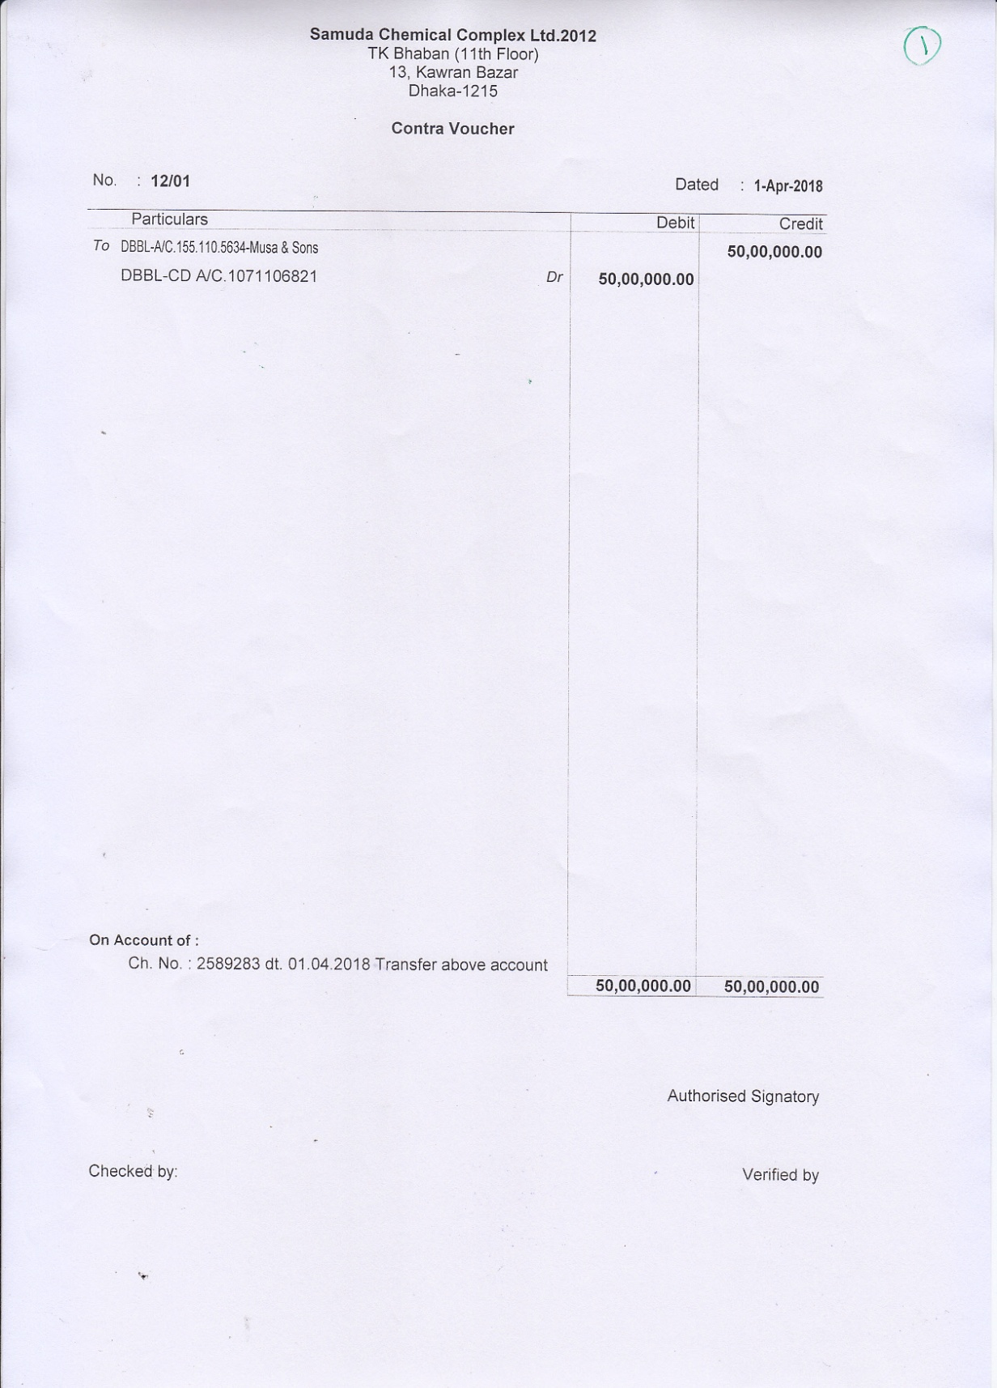

## **2. Bank Payment Voucher:**

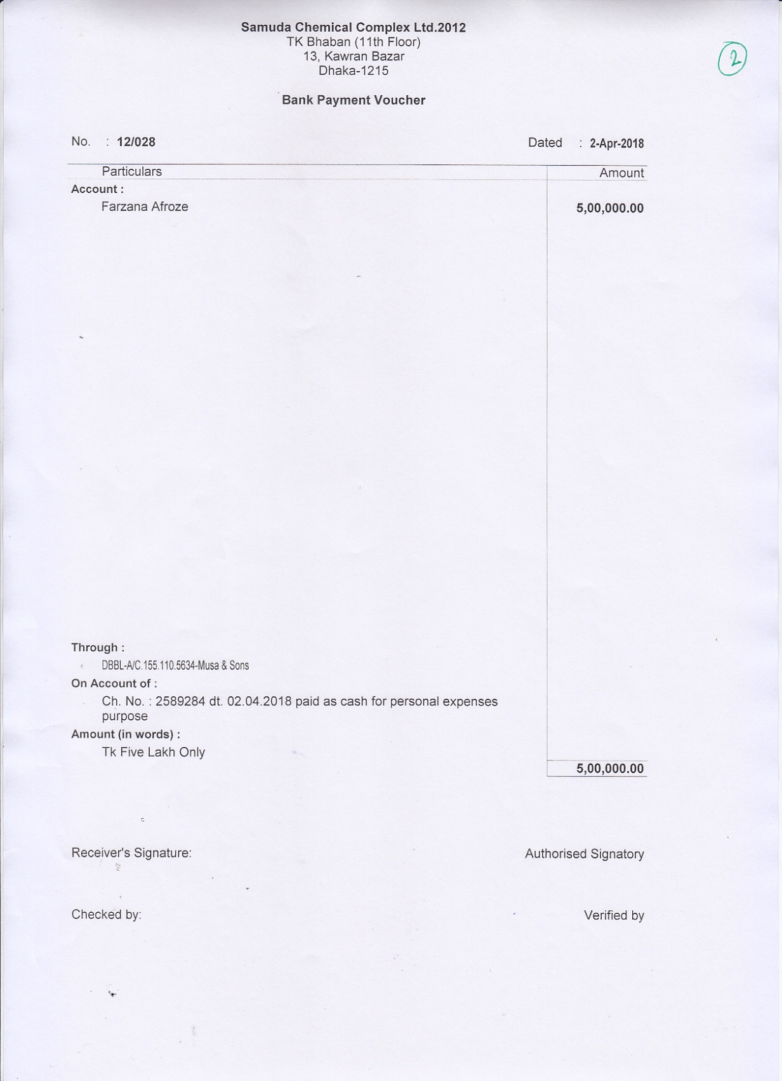

## **3. Bank Receipt Voucher:**

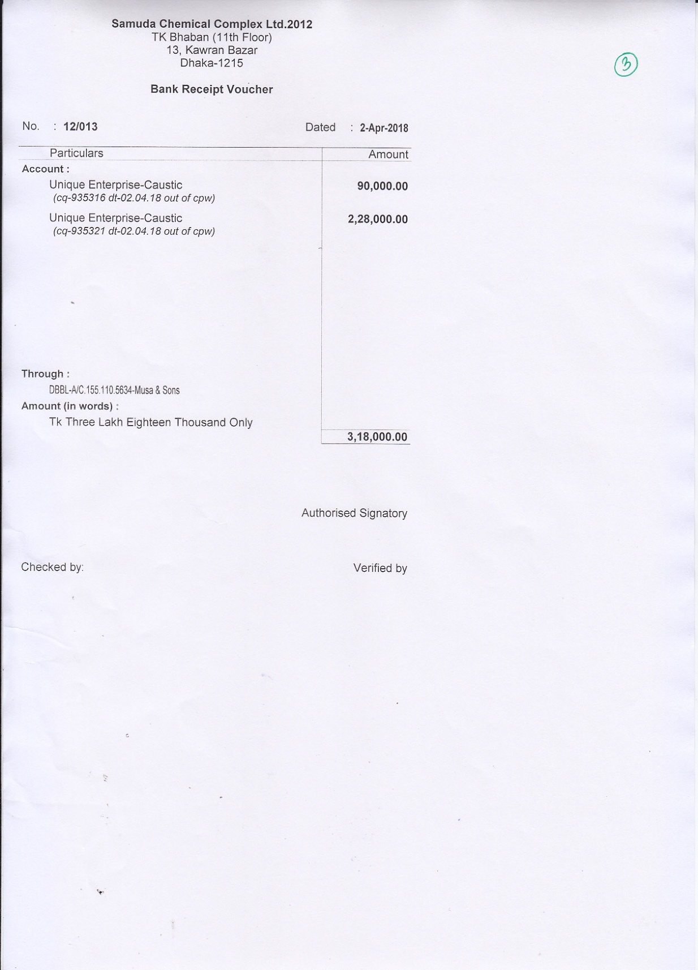

## **4. Journal Voucher:**

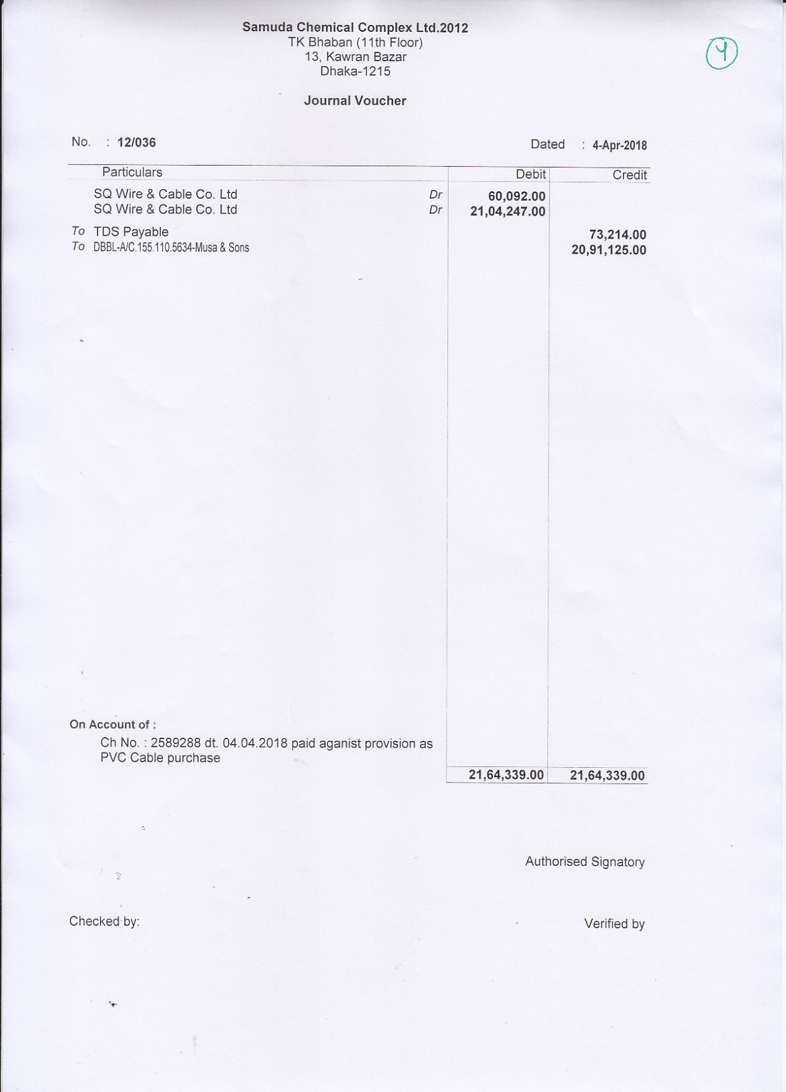

## **5. Balance Sheet**

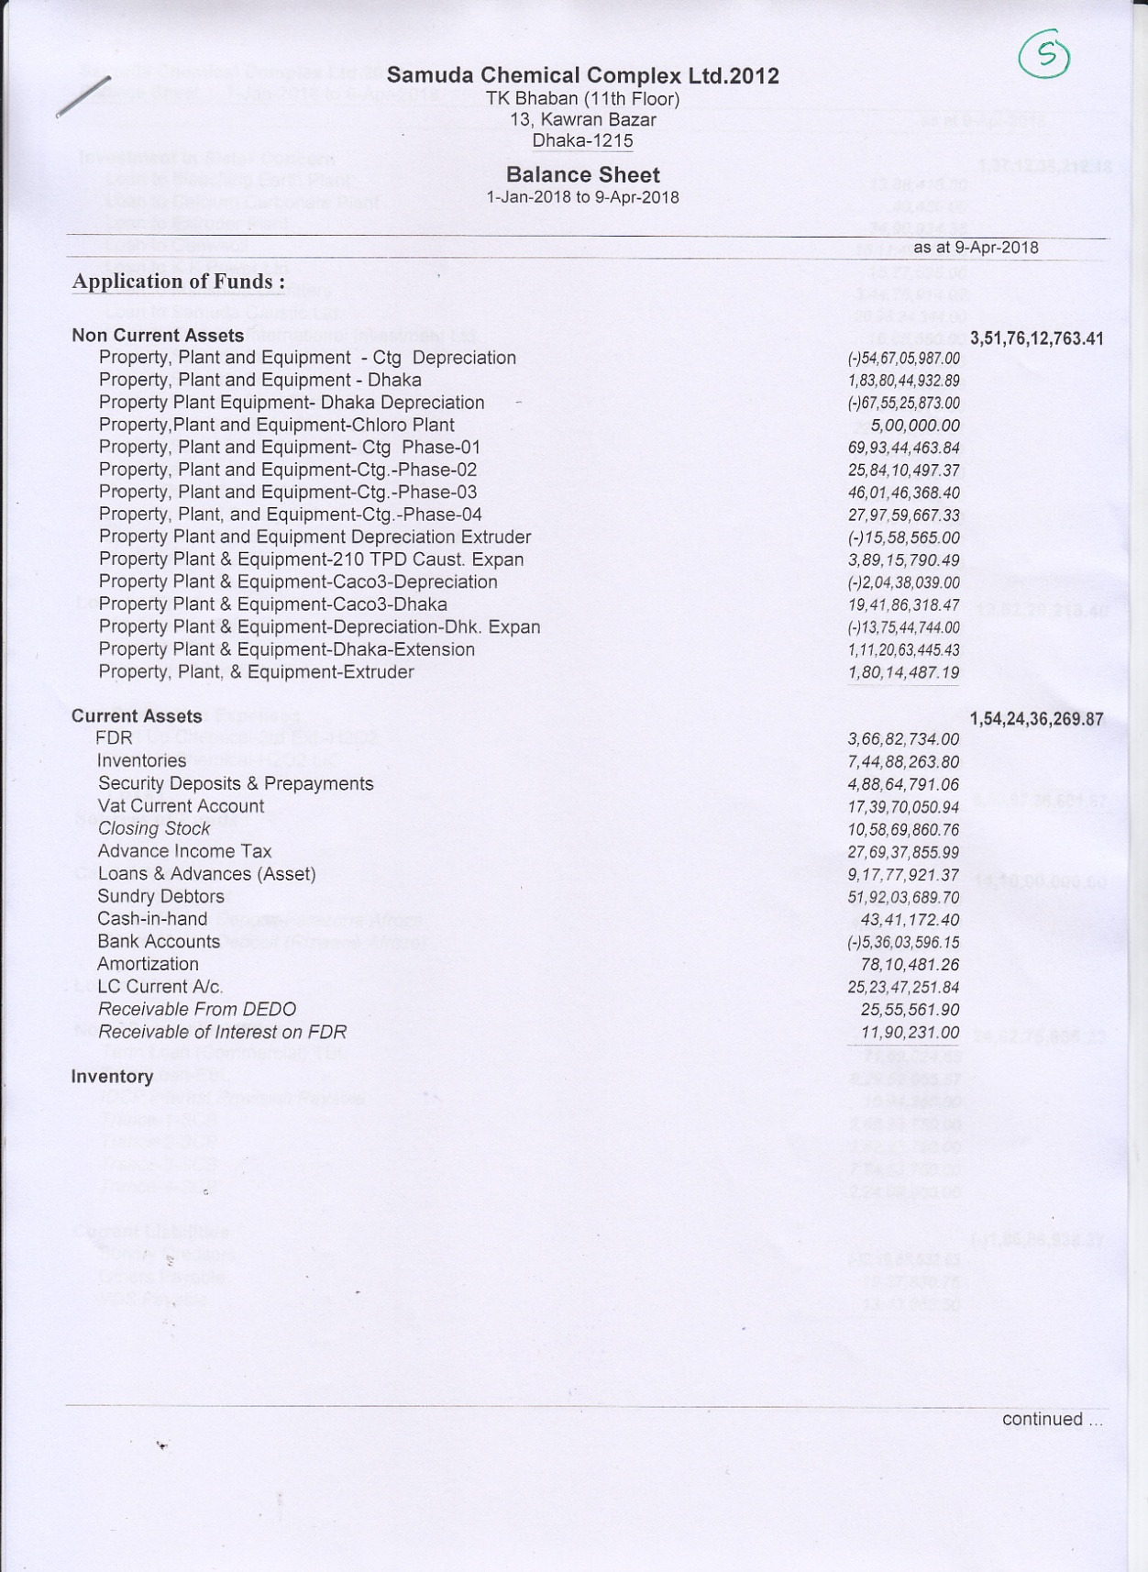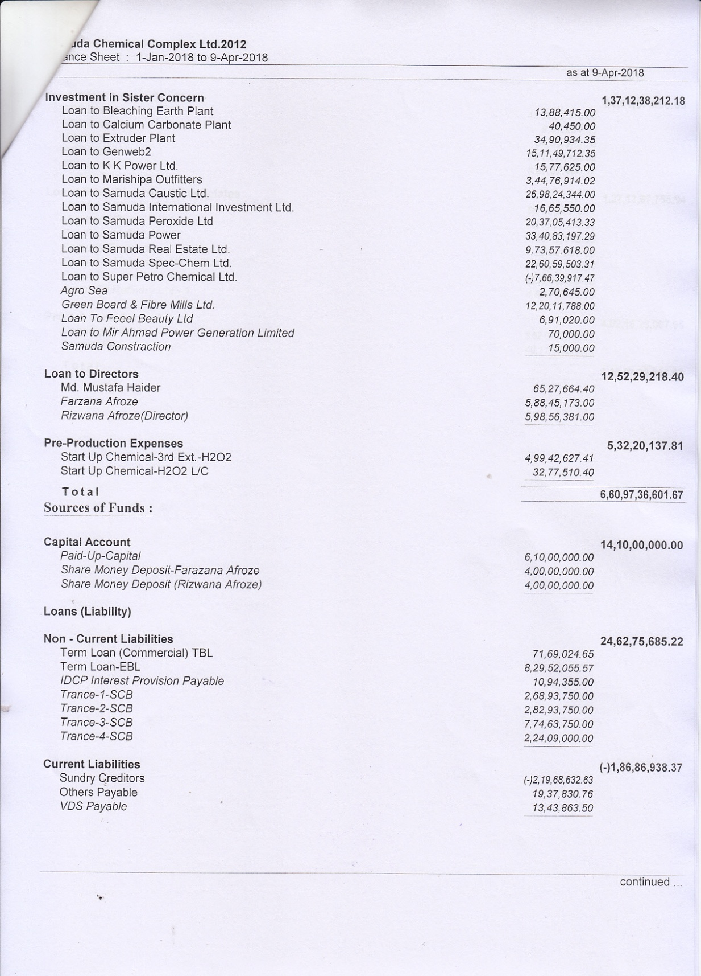

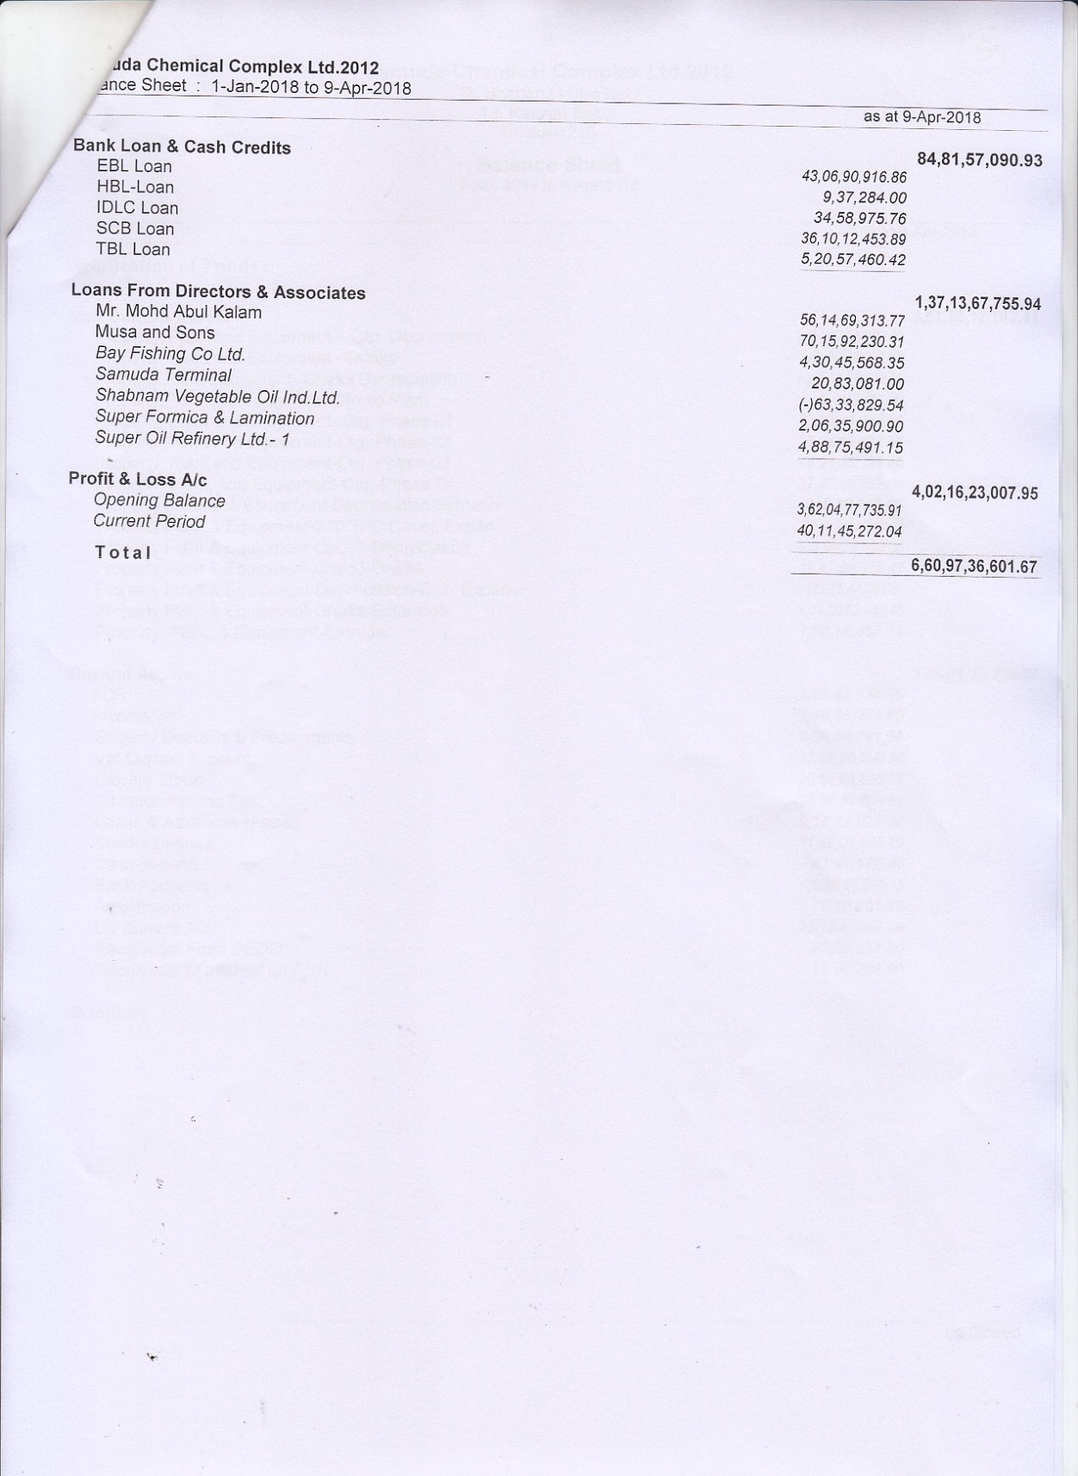

## **6. Profit & Loss Statement:**

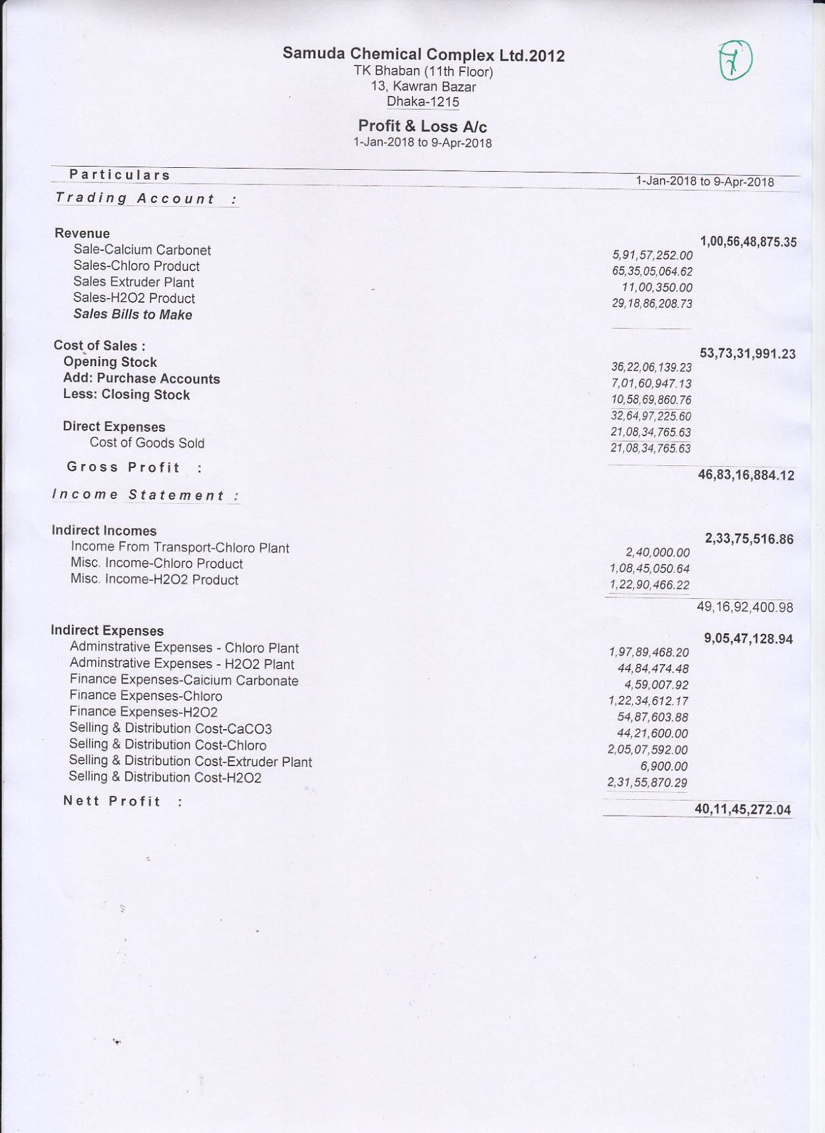

## **7. Group Summary:**

Group Summary of Indirect Expenses

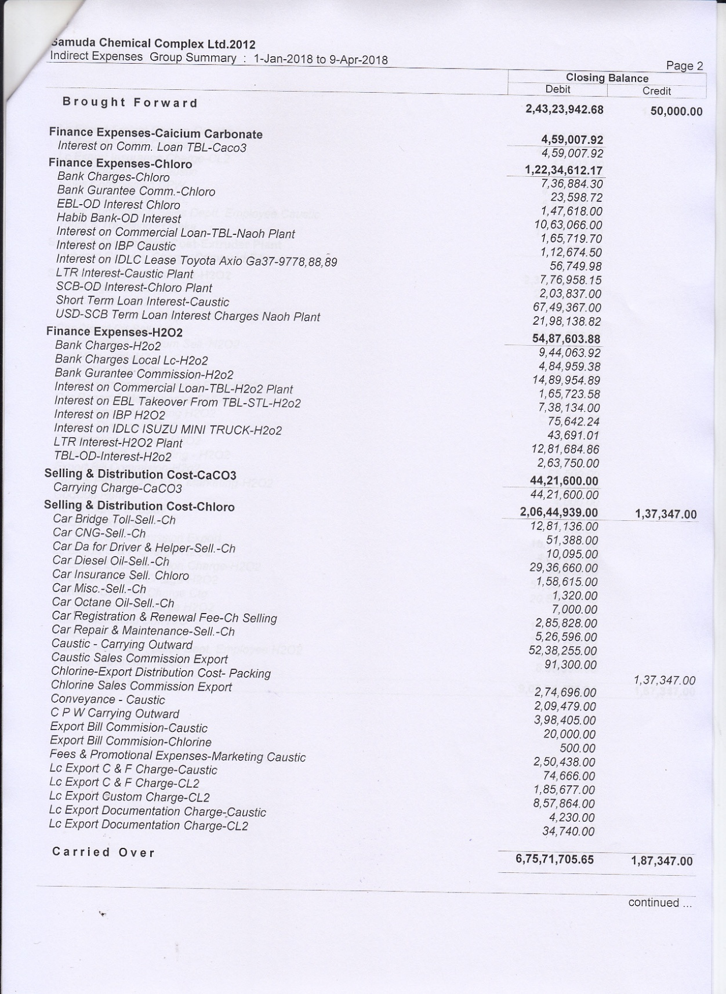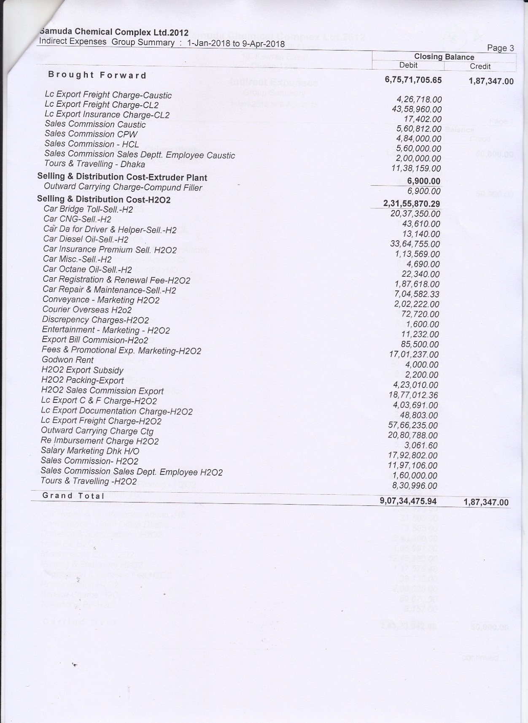

Group Summary of Revenue

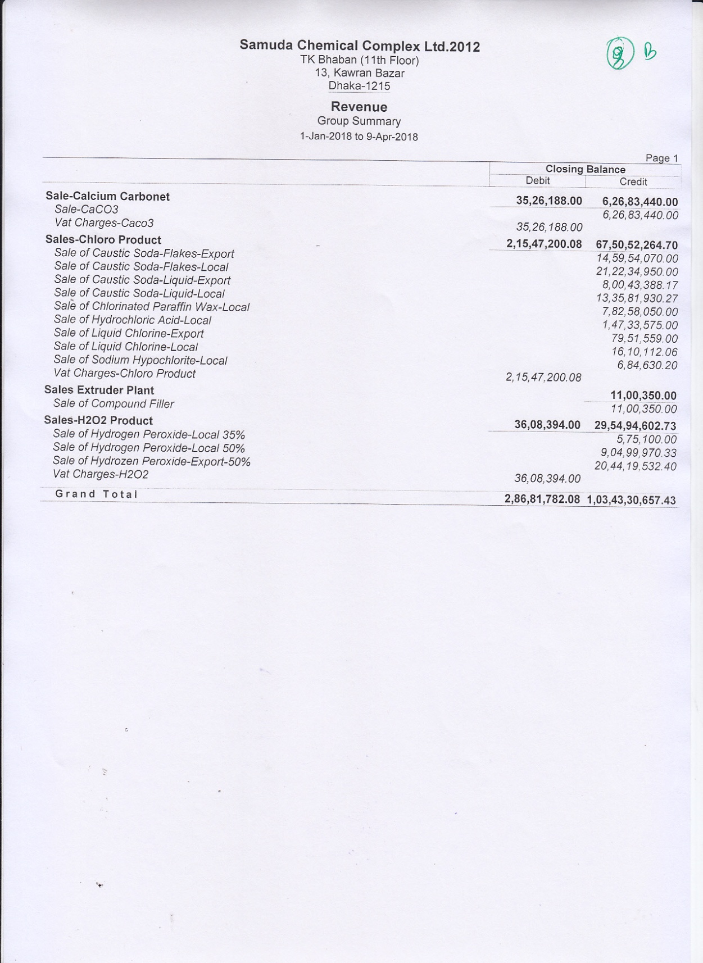

## **8. Cash Flow Summary:**

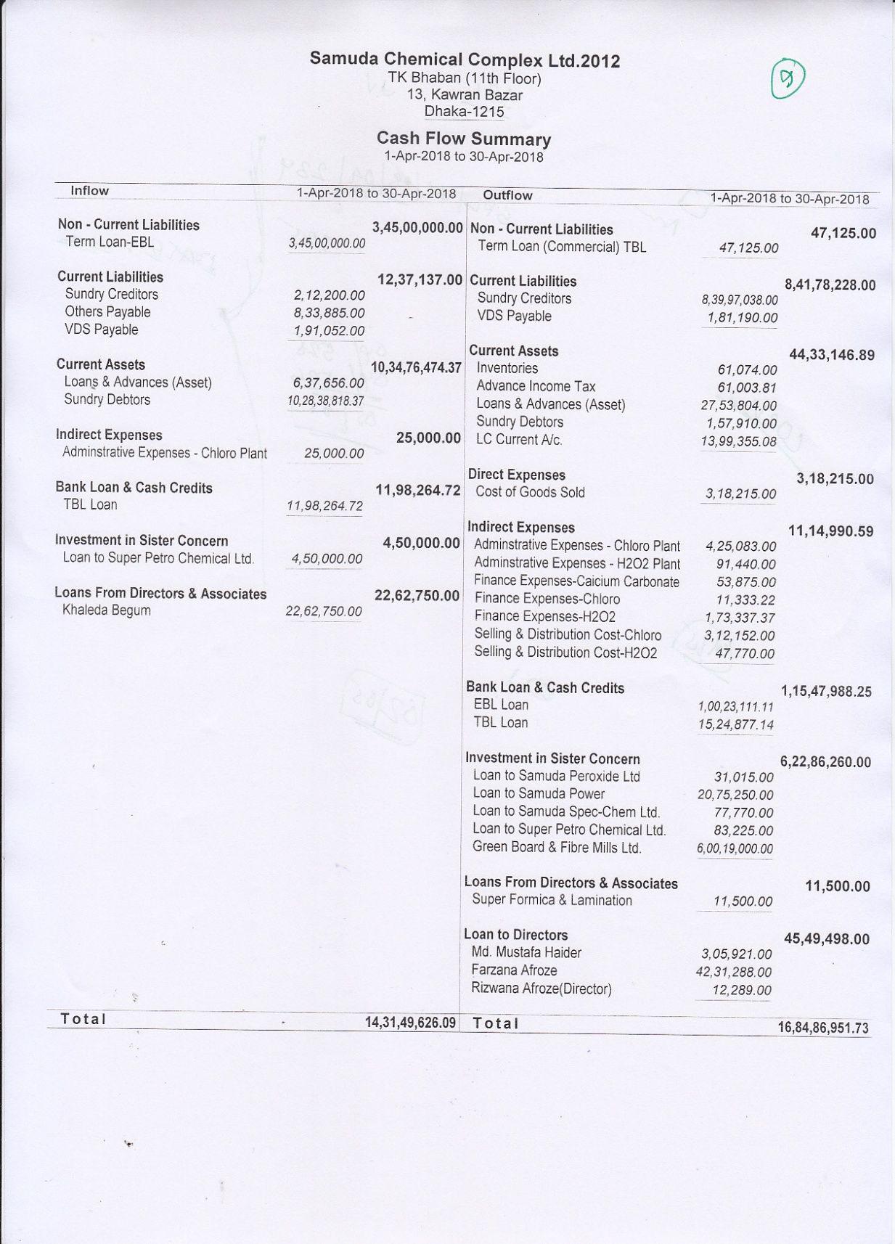

## **9. Account Ledger Report:**

